### **Team Saturday**

Team Members [ Ryker Chorley, Huey Shin, Hayden Shin ]

### **1. Define the Problem: "Permanent Erasure"**

Vandals don't want to sell the history; they (often accidentally or out of boredom) destroy it.

* **The Problem:** Archaeological sites (like cave paintings or ancient stone walls) are often in open areas. People might spray paint "I was here," carve names into stones, or knock down walls for fun.
* **The "No Undo" Button:** Unlike a modern building, you can't just use "paint thinner" on a 5,000-year-old cave painting. The chemicals in the cleaner would destroy the ancient art underneath.
* **The Speed:** Vandalism happens in seconds. A looter might spend hours digging; a vandal needs only 10 seconds to ruin a site with a can of spray paint.

Vandals put public access to Rainbow Canyon in southern Utah at risk

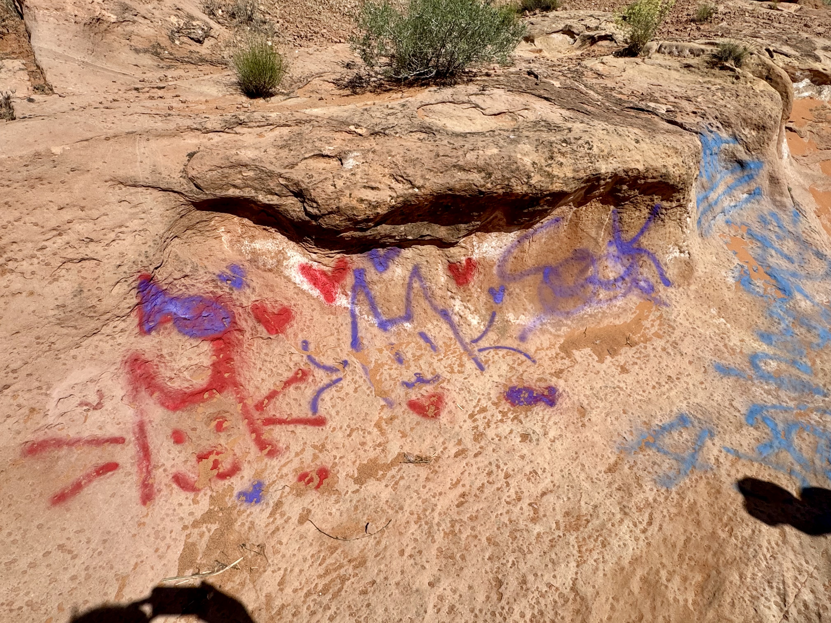

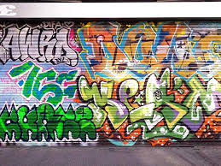

# [Graffiti, spray paint vandalism discovered inside Arches National Park](https://www.fox13now.com/news/local-news/southern-utah/graffiti-vandalism-discovered-inside-arches-national-park-during-government-shutdown)

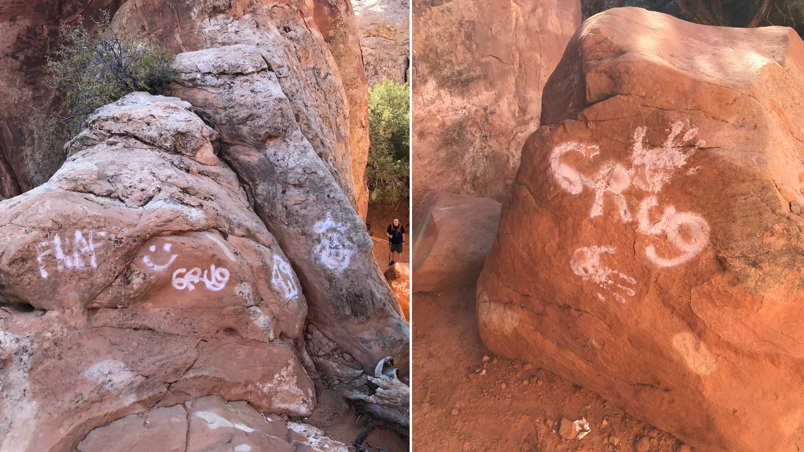

## 2. Refine the Solution: The "Acoustic & Visual" Site Guardian

Since vandalism happens so fast, your system needs to be **proactive** (stopping it *before* it happens) rather than just **reactive** (filming it while it happens).

**New Smart Features for Team Saturday to Research:**

* **Feature A: The "Hiss" Sensor (Acoustic AI):** Research microphones that can specifically recognize the sound of a **spray paint can**. There is software that can distinguish between a bird chirping and the "hiss" of an aerosol can or the "clink" of a hammer hitting stone.
* **Feature B: The "Virtual Fence":**e Instad of waiting for someone to touch the wall, use a "Lidar" or "Laser Curtain." If a hand crosses an invisible line 12 inches away from a cave painting, the system triggers.
* **Feature C: Active Deterrents (The Scarecrow Effect):**
  + **Voice Warning:** A speaker says: *"Warning: You are in a protected heritage zone. Your photo has been uploaded to the Ranger station."* (Most vandals will run away if they think they are being watched).
  + **Flash Lighting:** A bright strobe light can ruin their "art" and make it impossible for them to see what they are doing.

## 3. Real-World Research (Case Studies)

To impress the FLL judges, Ryker, Huey, and Hayden should look up these real-life examples:

1. **The Altamira Cave (Spain):** They had to close it because the breath (CO2) from tourists was "vandalizing" the art by causing mold to grow! (This is *accidental* vandalism).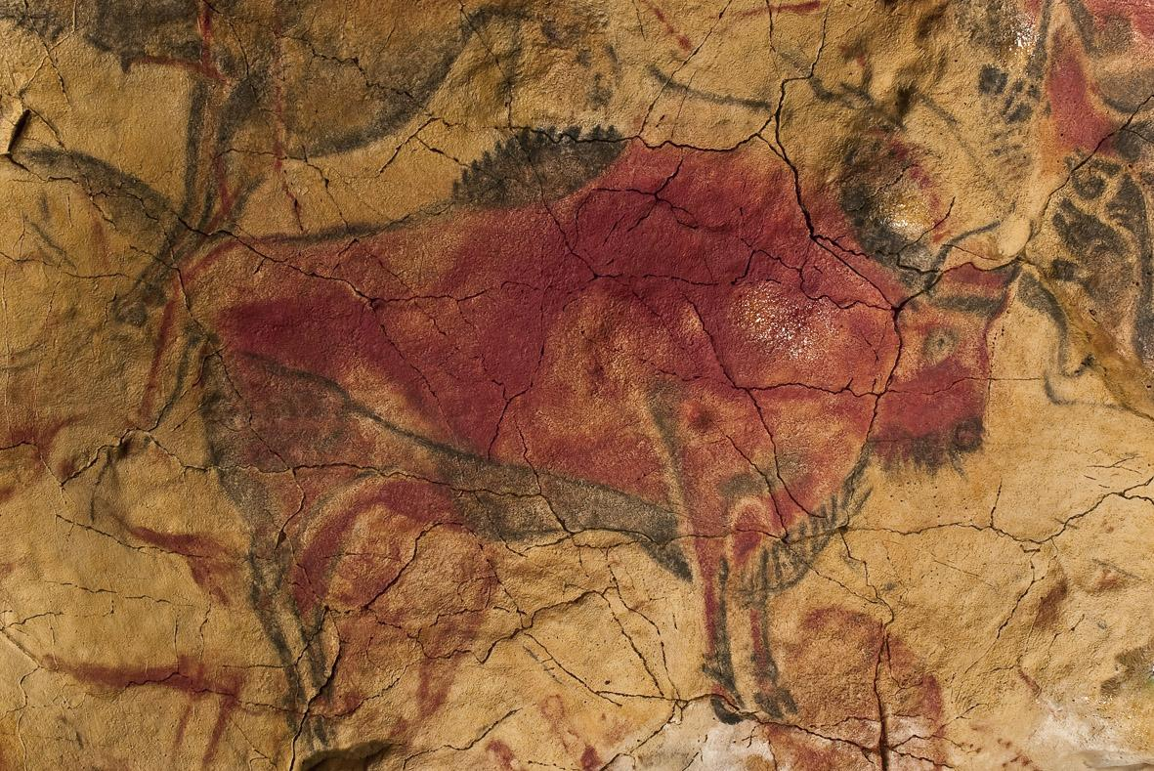
2. **Horseshoe Canyon (USA):** Look up how vandals spray-painted over ancient "Holy Ghost" pictographs.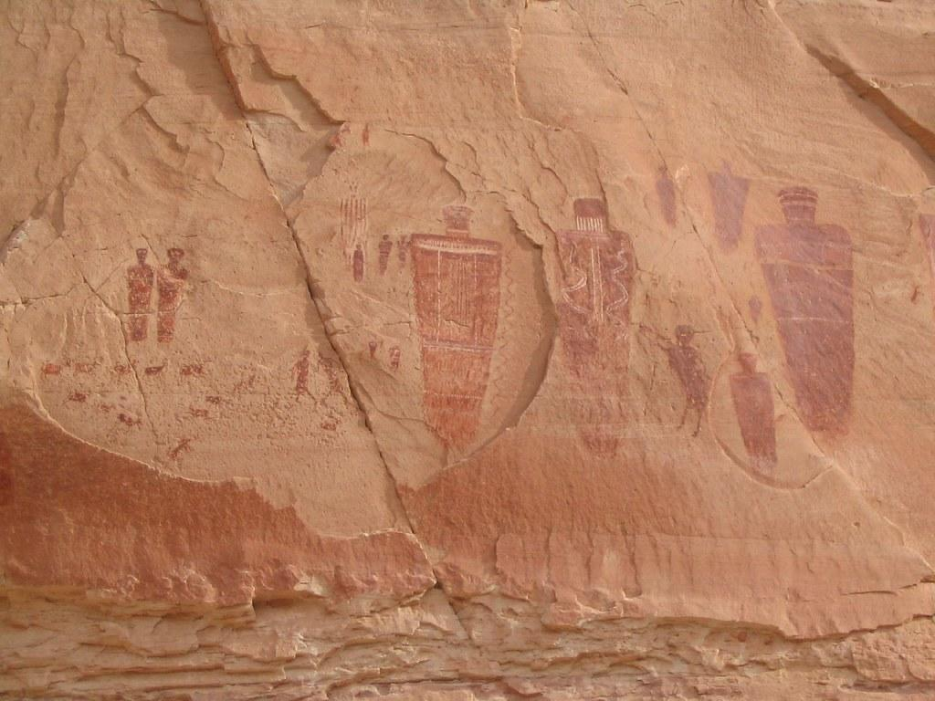
3. **The Roman Colosseum:**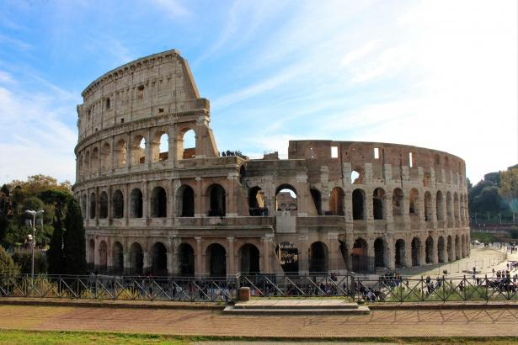 Every year, tourists get arrested for carving their names into the stones with keys.

**Expert Question to ask:** *"How do you clean graffiti off an ancient rock without destroying the rock itself?"* (The answer is: It’s almost impossible/very expensive!)

## 4. Prototyping with LEGO

You can build a "Wall Protector" version of the Site Guardian:

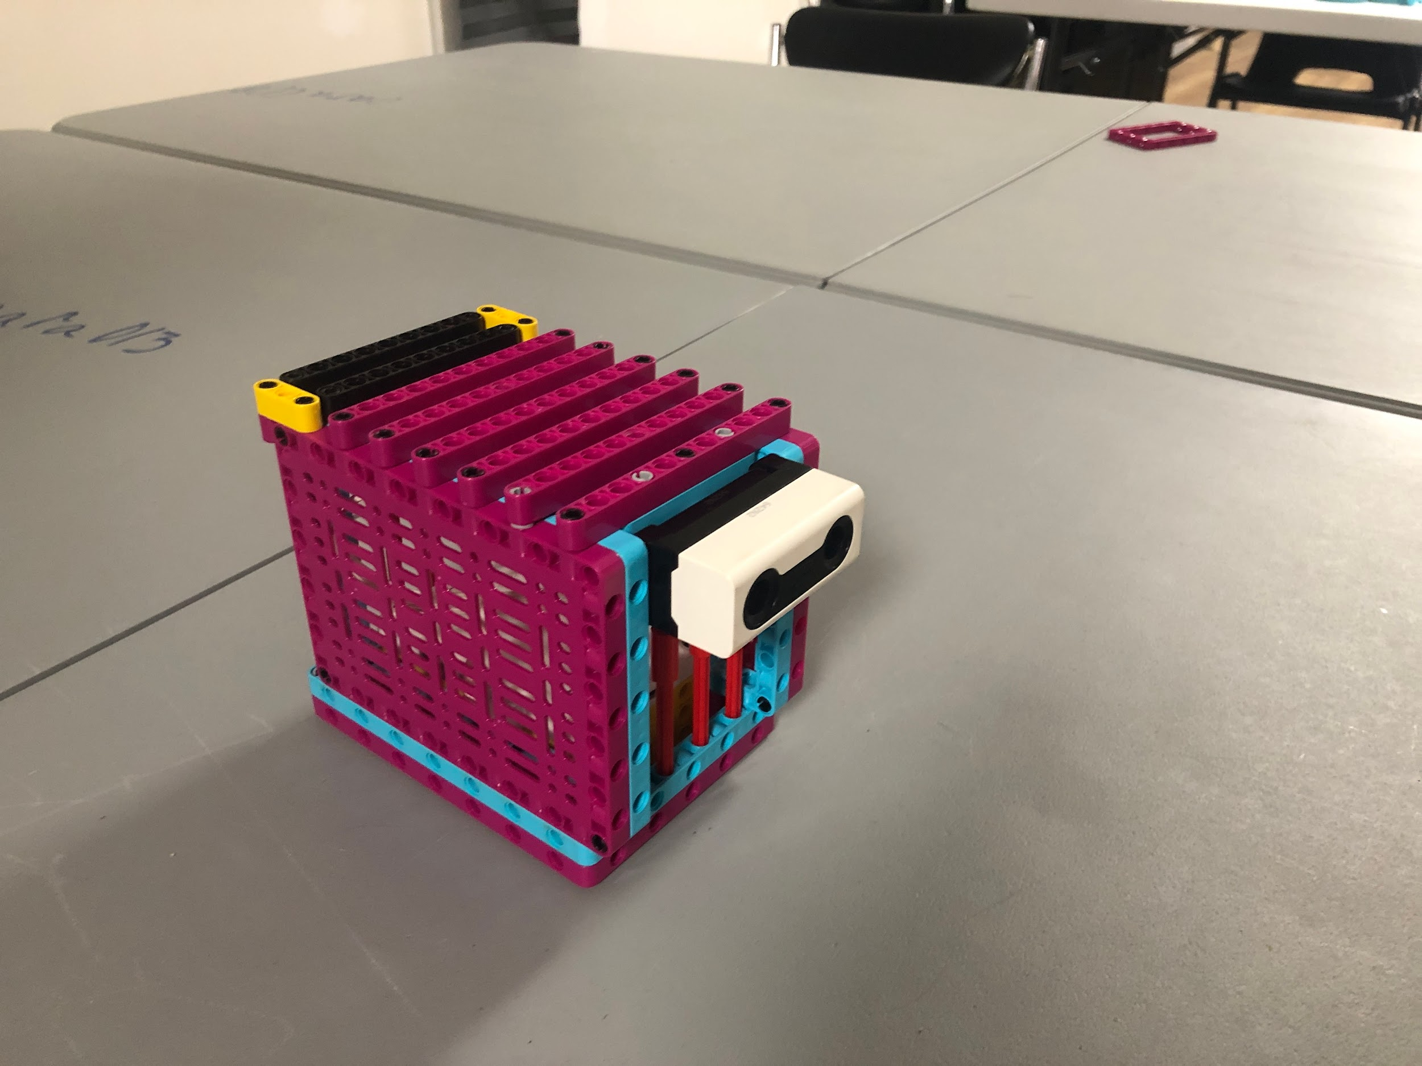

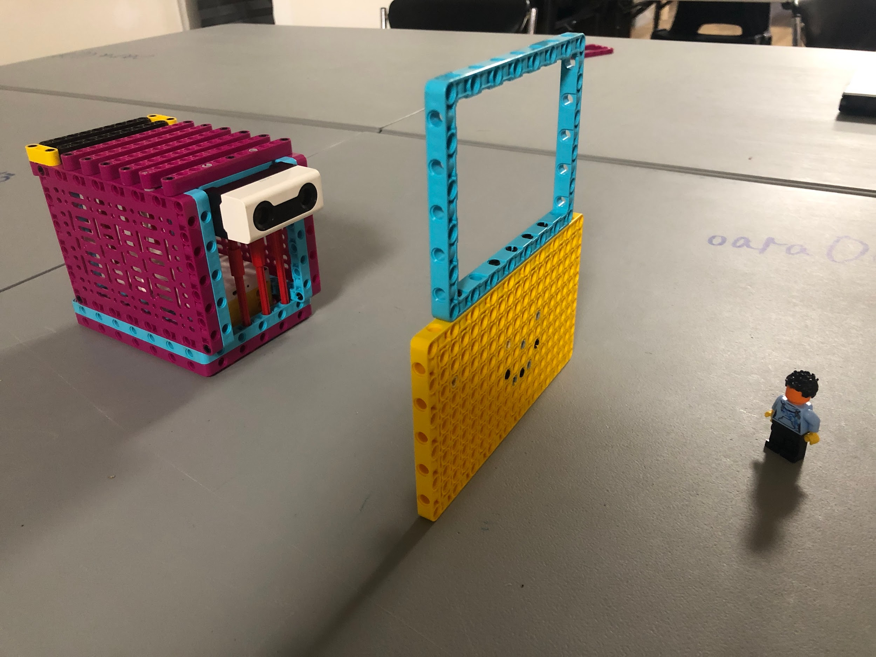

* **The Build:** Build a LEGO ancient wall or "Stonehenge."
* **The Sensor:** Use the **Distance Sensor** (Ultrasonic).
* **The Code:**
  + If something is 20cm away: Do nothing (the person is just looking).
  + If something gets closer than 5cm: The Hub flashes red lights and plays a "BEEP BEEP" sound (The Warning).
  + **The "Smart" part:** Have the Hub send a message to a second Hub (The Ranger Station) to show that a "Vandalism Event" is happening.

## 5. Your Team’s "Project Story"

When you stand in front of the judges, start with this:

*"Most people think looters steal history. But vandals erase it. We are Team Saturday, and we realized that a spray can is more dangerous than a shovel. Our 'Site Guardian' is designed to detect the sounds and movements of vandalism before the first drop of paint hits the stone."*

### **Suggested Tasks for the Boys:**

* **Ryker:** Research "Sound Recognition AI"—can a computer tell the difference between a spray can and a soda can opening?
* **Huey:** Look into "Non-damaging deterrents." What can we use to scare vandals away that won't hurt the environment (like bright lights or high-pitched sounds)?
* **Hayden:** Design the "Virtual Fence" using the LEGO sensors. How close can someone get before the alarm goes off?

For an FLL presentation, images shouldn't just be "pretty"—they should tell a story and prove you’ve done your research.

Here is a list of specific images Ryker, Huey, and Hayden should look for (or create) to make their presentation look professional and convincing.

### **1. The Problem: "History Under Attack"**

* **Graffiti on Petroglyphs:** Search for images of "Vandalized ancient rock art" or "Graffiti on Moab petroglyphs." These show bright spray paint over 2,000-year-old carvings. It’s a very powerful visual.
* **Carvings on Walls:** Look for "Vandalism at the Colosseum" or "Names carved in Great Wall of China." This shows that even famous sites are not safe.
* **The "Cleaning" Fail:** An image of archaeologists trying to use a tiny toothbrush or laser to clean stone. This proves how hard and expensive it is to fix vandalism.

### **2. The Science: "Why it’s Permanent"**

* **Microscopic Rock Surface:** A zoomed-in photo of sandstone. It looks like a sponge. Explain to the judges: *"Look at these pores. When paint hits this, it sinks in deep. You can't just wipe it off."*
* **The "Hiss" Graph (Spectrogram):** Look for a "Spectrogram of an aerosol spray can." It looks like a colorful wave. Compare it to a "Spectrogram of a bird chirping." This shows how your AI "Site Guardian" can tell the difference between nature and a vandal.

### **3. The "Site Guardian" Technology**

* **Lidar/Virtual Fence:** Find a diagram of a "Laser Curtain" or "Lidar boundary." It usually shows a red grid over an area. This helps the judges visualize your "Virtual Fence."
* **Game Camera Examples:** Find a photo of a "Trail Camera" strapped to a tree. You can point to it and say: *"Current cameras are too bulky and easy for vandals to see and smash. Our Site Guardian is hidden."*
* **Seismic Sensor:** A photo of a small industrial vibration sensor. It looks like a small metal cylinder. Explain that this stays underground where vandals can't find it.

### **4. Your Team’s Work (The Most Important Images!)**

* **The "Deep Work" Photo:** A photo of the three of you (Ryker, Huey, Hayden) around a table with LEGO parts and laptops, looking serious. Judges **love** seeing the team actually doing the work.
* **The Prototype Close-up:** A high-quality photo of your LEGO "Site Guardian" model. If you built a "LEGO Rock" to hide the sensor, show it both "Open" (to see the tech) and "Closed" (to show how it’s hidden).
* **Screen Snippets:** If you wrote code in SPIKE Prime or EV3, take a screenshot of the blocks. It proves you did the programming yourselves!

### **5. Diagrams to Create (On a Poster or Slide)**

* **The "Action-Reaction" Flowchart:**
  + *Trigger:* Sensor hears a "Hiss" or sees a hand cross the "Virtual Fence."
  + *Action 1:* Hub sends a "Silent Alert" to the Ranger.
  + *Action 2:* Speaker plays a "Voice Warning" to scare the vandal.
  + *Action 3:* Camera takes a high-res photo for evidence.

### **🎨 Pro-Tip for your Presentation Slides:**

If you want to create your own "High-Tech" looking images, you can use a free AI image generator (like Canva or Bing Image Creator) with these prompts:

* *"An ancient cave painting protected by a glowing blue holographic laser fence, cinematic lighting."*
* *"A small, camouflaged high-tech security sensor hidden inside a realistic-looking desert rock."*
* *"A digital dashboard showing a map of an archaeological site with a red alert flashing 'Vandalism Detected'."*

### **How to use these in the room:**

* **Ryker:** Can hold the "Problem" images and explain the loss of history.
* **Huey:** Can show the "Spectrogram" and explain the smart sound-sensing tech.
* **Hayden:** Can show the LEGO Prototype and explain how the "Virtual Fence" works.

Here is a complete **5-minute presentation script** customized for **Team Saturday** (Ryker, Huey, and Hayden).

This script is energetic, focuses heavily on the "Science" of the problem (as outlined in your notes), and uses the specific research tasks assigned to each boy.

**Props Needed:**

1. **The LEGO Model** (The "Site Guardian").
2. **Images:** Large printed photos of graffiti on rocks and a "Spectrogram" (sound wave) chart.
3. **A Spray Can** (Empty/Clean) for a sound effect prop.
4. **A "Do Not Touch" Sign**.